**KAMPALA PARENTS’ SCHOOL 2004**

**END OF YEAR ASSESSMENT, 2018**

**DRAWING – TOP CLASS**

**Name: ______________________________ Group: ________**

1. 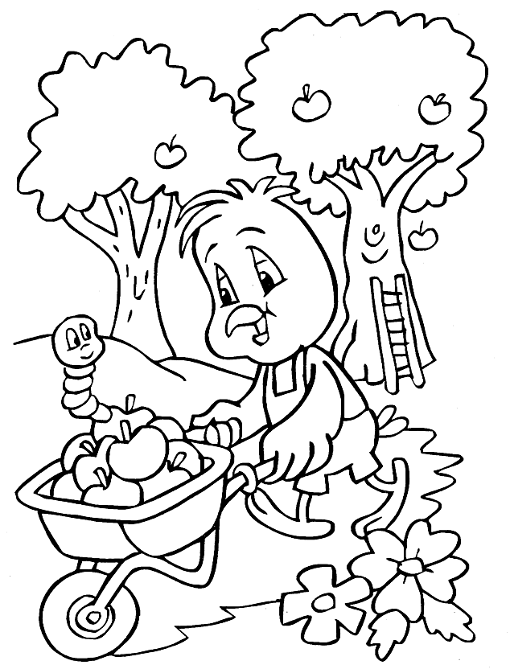**Colour the picture.**
2. **Draw a picture for “the day I visited the zoo.’**